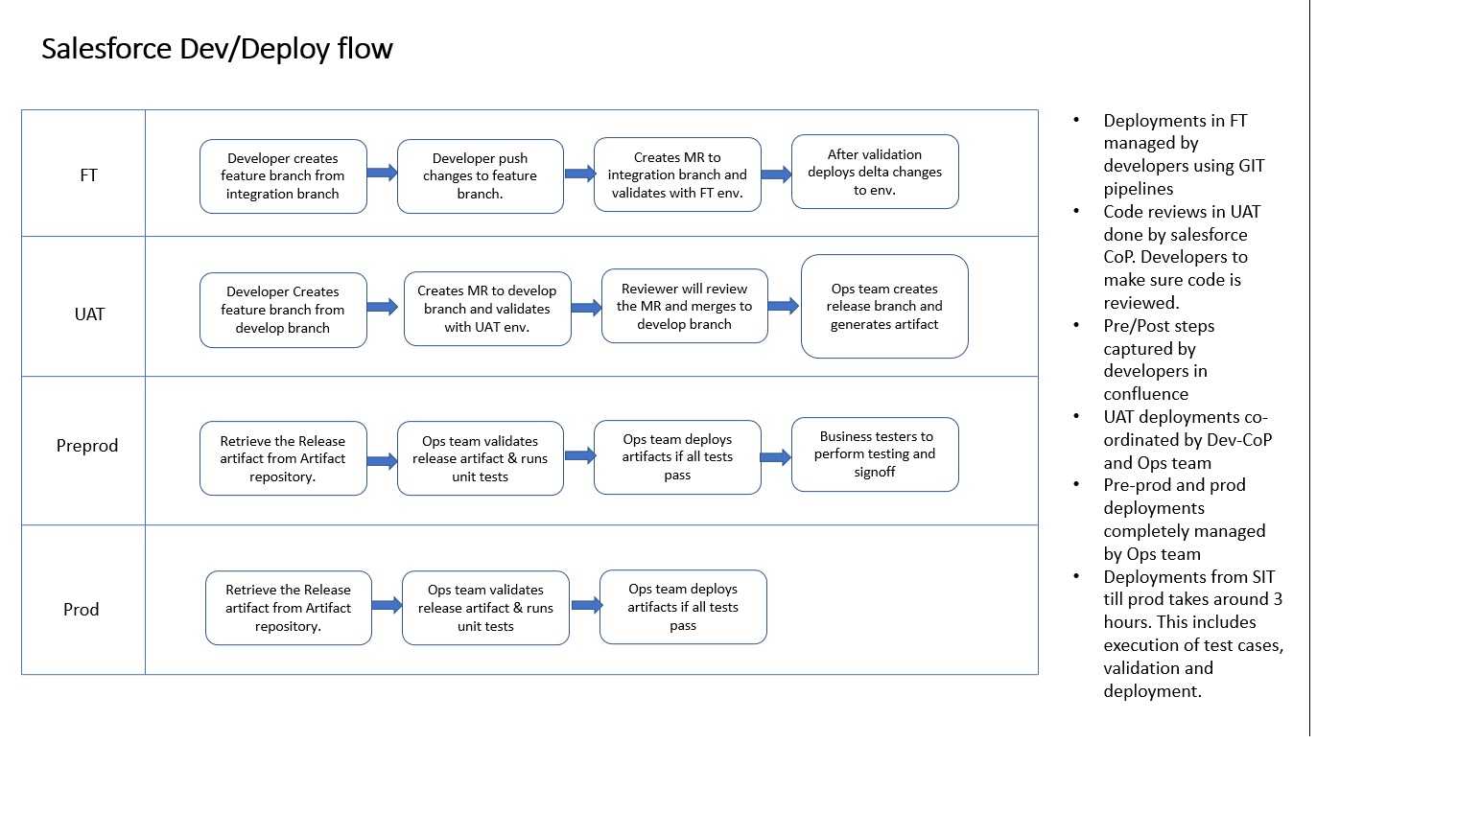

What is CICD?

Release management

Tools support CICD (GitLab, Genkins)

What Pipelines

How do we write pipelines for SFDX deploy.

YML file